**Implementing CRM for result tracking of a candidate with internal mark**

**1. introduction**

**1.1 over view**

**Administrator should be able to create all base data including semester, candidate, course and lecturer, lecturer should have tha ability to create internal results.**

**1.2 purpose**

**The only with ability to update internal result re-evaluation can be initialized by candidate for all internal results. Now only deam can update the marks after re-evaluation.**

**2. problem definition &design thinking**

**2.1 Empathy map**

**The Essentially, an empathy map is a square divided into four quadrants with the user orclient in the middle. Each of the four quadrants comprises a category that helps us delve into the mind of the user. The four empathy map quadrants look at what the user says, thinks, feels, and does.**

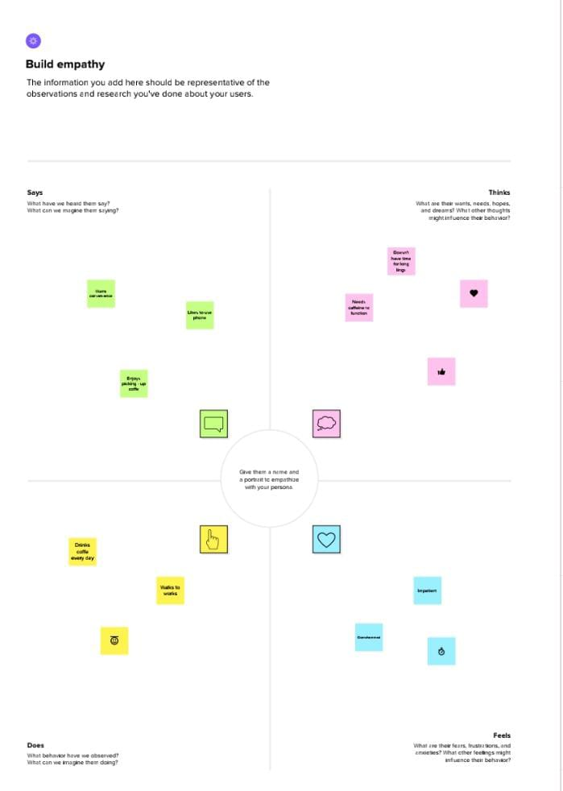

2.2 Ideation & brainstorming map:

Brainstorming is a group problem-solving method that involves the spontaneous contribution of creative ideas and solutions. This technique requires intensive freewheeling discussion in which every member of the group is encouraged to think aloud and suggest as many ideas as possible based on their diverse knowledge.

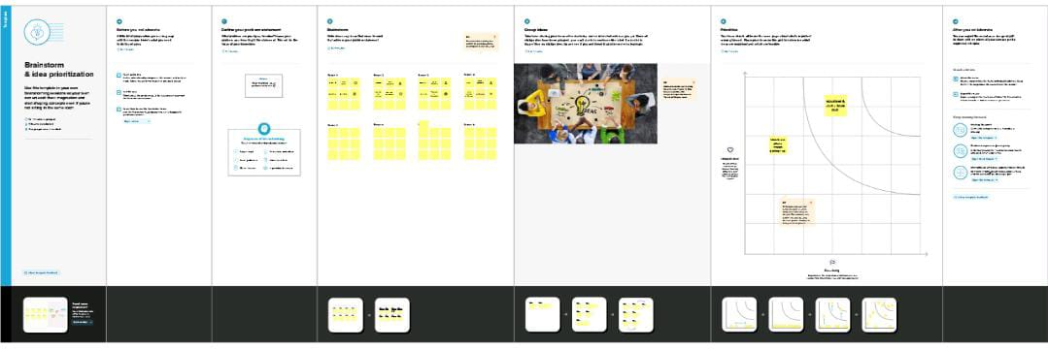

3. Result

3.1 Data mode:

|  |  |
| --- | --- |
| Object name | Fields in the object |
| Obj 1 | |  |  | | --- | --- | | Field label | Data type | | semester | text | | Candidate | text | |
| Obj 2 | |  |  | | --- | --- | | Field label | Data type | | Internal results | Text (80) | | Lecturer details | Text (80) | |

3.2 Actvity & screenshot :

Activity -1 : (semester ) 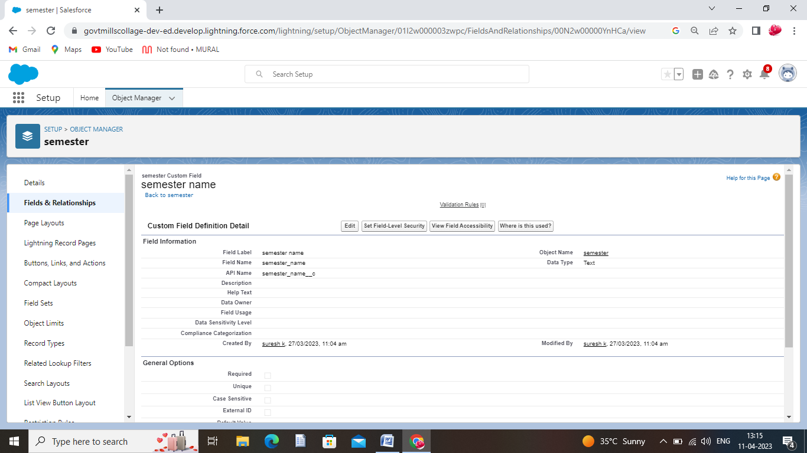

Activity -2 : (Candidate)

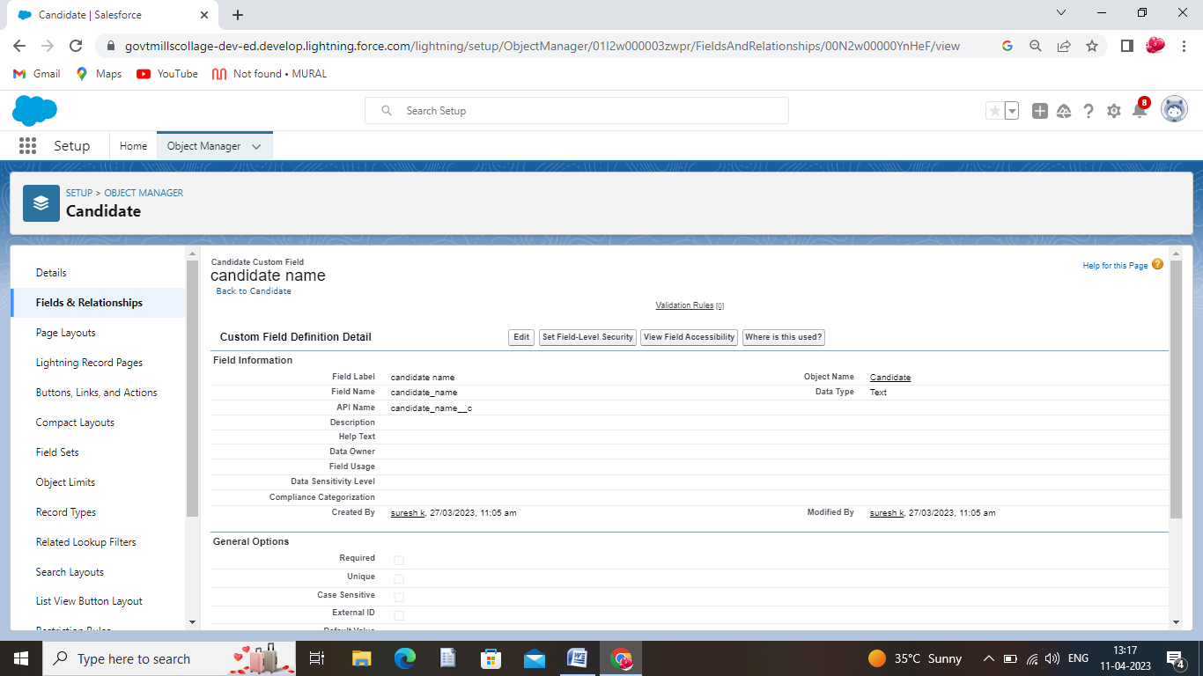

Activity -3 : (Internal results)

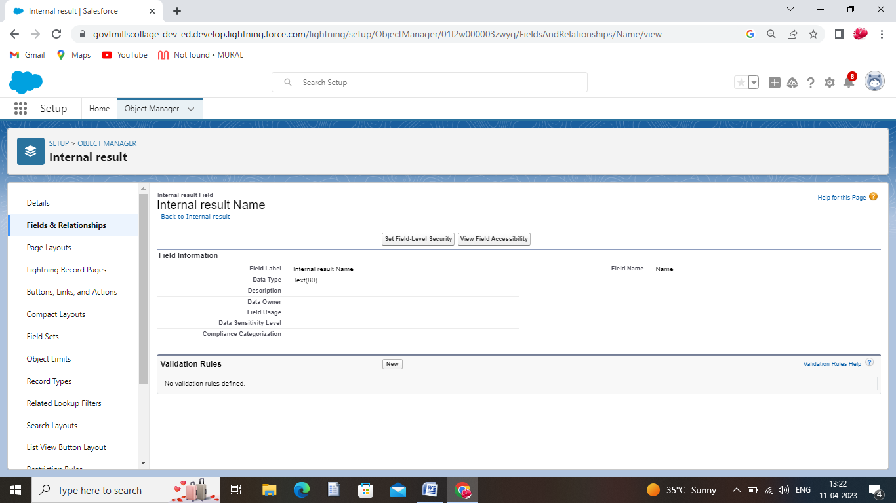

Activity -4 : (Lecturer details)

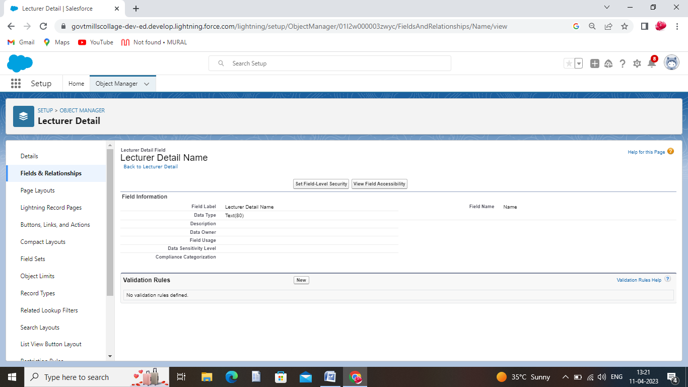

4. Trailhead profile public URL:

Team lead –<https://trailblazer.me/id/ssuresh219>

Team member 1-<https://trailblazer.me/id/sarar128>

Team member 2-<https://trailblazer.me/id/sridr16>

Team member 3-<https://trailblazer.me/id/suryb6>

Team member 4-<https://trailblazer.me/id/santk46>

5. ADVANTAGES & DISADVANTAGES:

* 1. ADVANTAGES :

* It allows for the consolidation of customer data and the basis for deep insights.

* It speeds up the sales conversion process.

* It increases staff productivity, lowering time-cost.

* It allows geographically dispersed teams to collaborate effectively.

* the Improves customer experience by allowing personalisation and improved query resolution.

* 1. DISADVANTAGES :

* Customer experience may worsen due to staff over-reliance on the system.

* Security and data protection issues with the centralised data.

* The excess initial time and productivity cost at the implementation.

* Requires a process-driven sales organisation.

* CRM may not suit all businesses

6. APPLICATIONS :

1. Set realistic, actionable goals. ...
2. Do your research to find the right CRM solution. ...
3. Select a CRM team, with department champions. ...
4. Forecast the costs and benefits. ...
5. Migrate and integrate data. ...
6. Train the team and test the system.

7.CONCLUSION:

* Customer Relationship Management **enables a company to align its strategy with the needs of the customer in order to best meet those needs and thus ensure long-term customer loyalty.**

8.FUTURE SCOPE:

* These days, numerous small and medium-sized enterprises are arising across the world. Unlike large organizations, they are reluctant to implement CRM software. However, the preferences and requirements might change with time. There was a time when CRM used to be meant for expensive infrastructure and complex technicalities. These, in turn, increased the expense of the CRM software and made it unaffordable for companies which have a small investment.